**Processing WC miniPAT tags in DAP to get GPE2 - Final Method**

**NB: this method is for processing miniPAT tags only…**

1. Open DAP > File > Import Tag Data > From File > choose .wch (for fully transmitted / recovered tags) or .prv or All.csv for non-recovered tags

2. Tags > Clock Corrections > check the clock corrections for the tags to ensure that they are in seconds and that first and last dates align with metadata deployment and pop-off dates. If the clock shows time corrections in hours, this is an issue and you need to let Wildlife Computers know because they need to do some additional processing on their end.

E.g. of a decent clock correction:

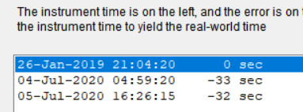

E.g. of poor clock correction



3. Open Tags > Light Level Global Position Estimator. This automatically starts to analyze the data ‘Abort Automatic Processing’ and select ‘Yes’ to continue processing the tag

4. Settings > Edit Deploy/Popup Information and enter the tagging and recovery times and locations from the metadata in the WC_DAP Global Position Estimator window

5. Lat-Long > ‘Recalculate Longitude for all messages’ > a pop-up will appear that says ‘Longitudes were only partially processed, do you wish to continue’ > Select No to start the process from scratch .

6. After this is finished > Lat-Long > ‘Iterate lat/lon for all messages’.   
**Note:** sometimes this option is greyed out (I am unable to select it for some tags) on my DAP? It seems like it may be for older tags? Still have not been able to work out a solution for this.

7. In the pop-up ‘Locations’ window select the Lat/Long option to show the map of positions that have been generated. Below is an example of the map that was generated for my BSH tag 177790. These are the positions after lat/long have been iterated and you will see that there are some points still on land (in Antarctica and Alaska). It is very important to not be subjective about removal of points. In this case, there is no chance that the BSH would be in Antarctica and this was most likely due to a spurious light level transmission (note that lots of unusual light level transmission data happen around the equinox in March and September of each year, this is something to keep in mind) . We are ok to remove this point in Antarctica.We want to be careful to not remove points subjectively (i.e. do not use the Keep off Land function to clean up data). Spurious points may only be removed if they are wildly out of the realm of possibility and likely drive by erroneous latitude values. The point in Alaska, even though its on land is within the same latitudinal boundary as the majority of the points, so we are going to keep it in , and let the model figure out that its erroneous rather than us.

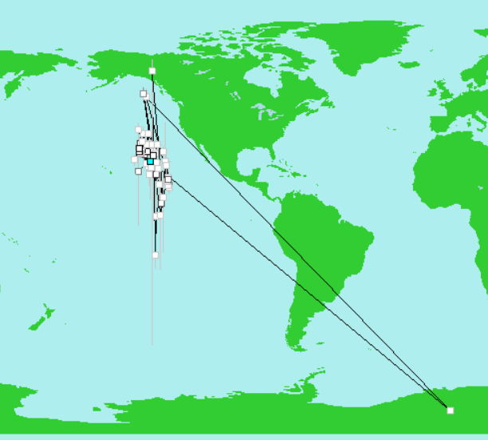

8. To remove spurious locations, select the dot on the map, this will highlight the point in blue and the row in blue on the main DAP screen > Select ‘Reject Record’

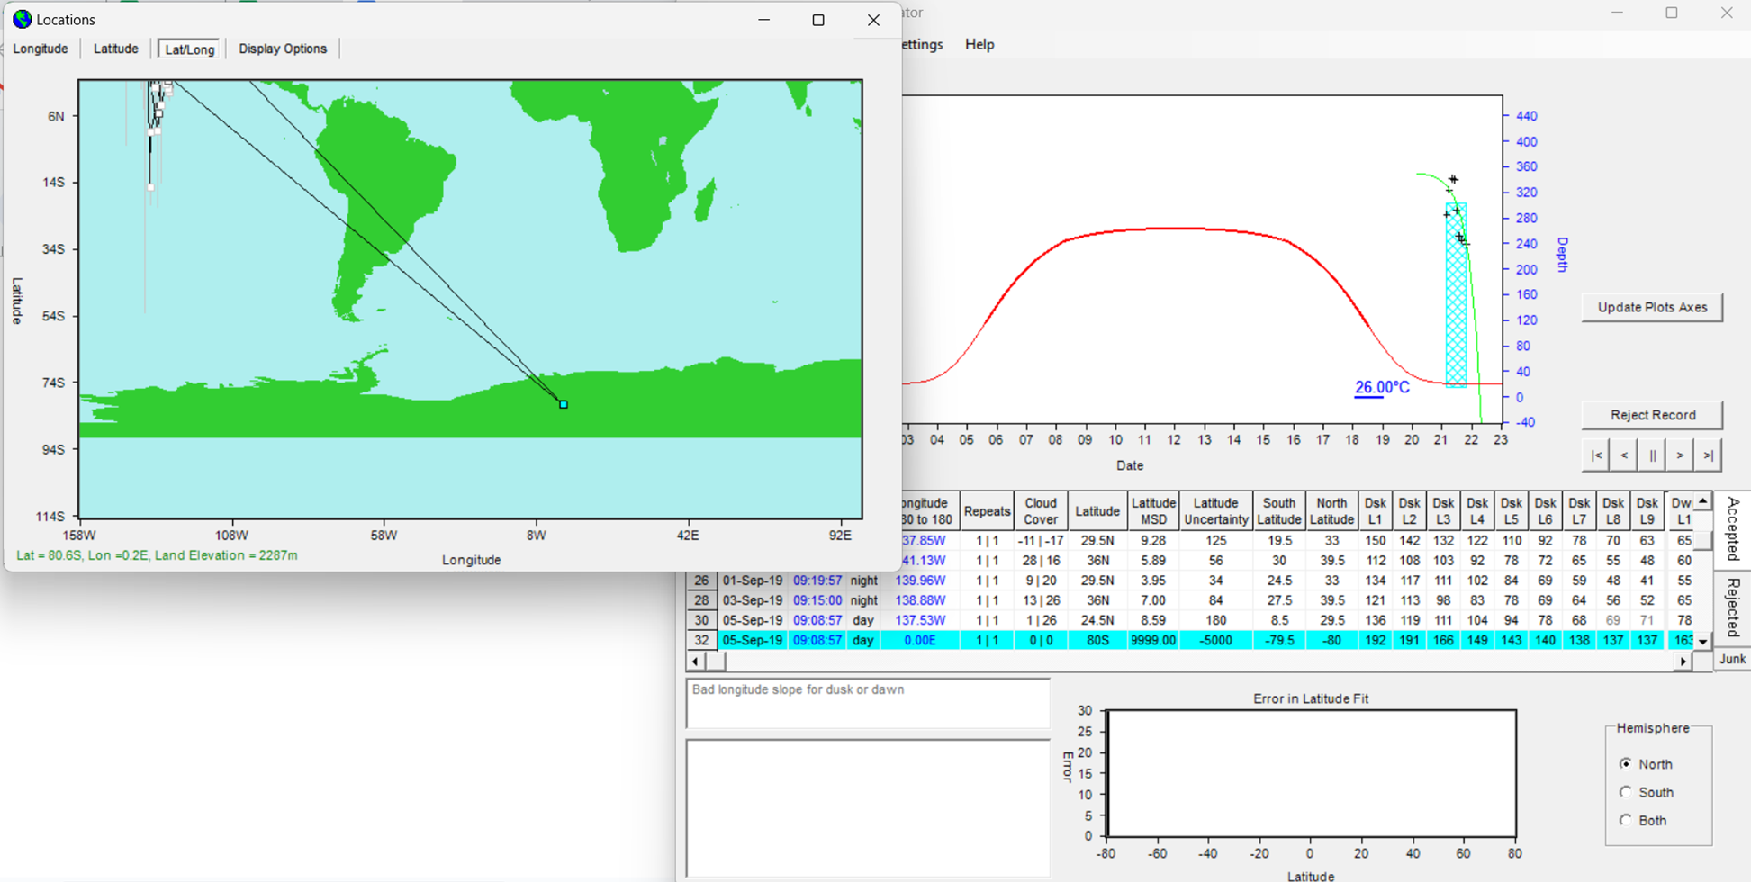

9. After the record has been rejected, the map looks like this.. This is OK. Even if there are points on land

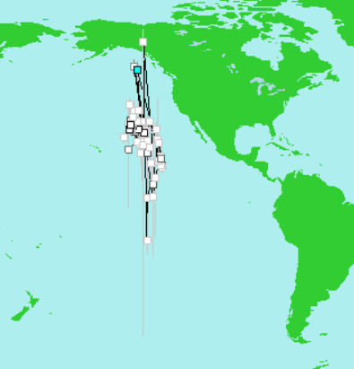

10. File > Save changes and close

11. File > Export decoded data > Spreadsheet file format .csv > So its less confusing with all my other runs. I save the exported GPE2 data as serial#no_GPE2.csv

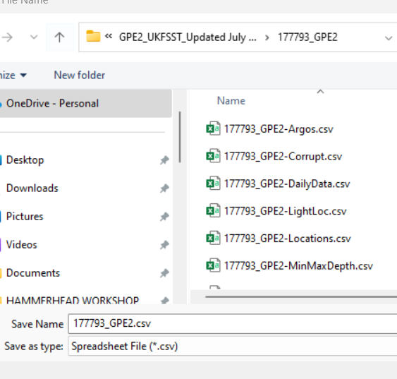

12. **This step is important.** We have to now open the newly created Locations.csv in and add in deployment date / time, latitude, longitude (from the metadata file) in the top row and pop-off date as the last row.. For some tags, this information gets added for others is does not. Make sure type is ‘User’. For the final row we want an Argos location (Quality = 3 is ideal which means it is more accurate, but using the first ARGOS location with a quality >=1 is more than sufficient as we are looking at broad scale movement and 1 mile means nothing, especially when you consider the error about each position estimate) that is as close to the pop-off date as possible, AND doesn’t have wildly different lat/long from the pop-off date. There will usually be more than 10 Argos locations at the end of the Locations .csv so select the one that is of high quality and as close to the pop-off location as possible.

Example of adding in the top row for deployment period:

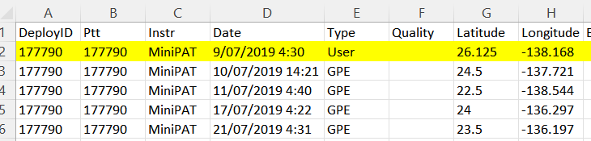

Example of selecting the final location on the bottom row as an Argos 3. It is ok to remove rows of .csv that are after the pop-off date.

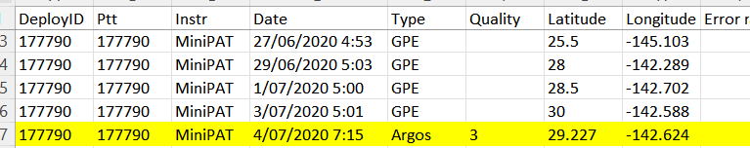

Make sure that the LightLocs.csv that was produced by the GPE2 run also has the same start / end deploy/pop-off information as Locations.csv. In the case of this tag, the DAP processing didn’t change the begin date to the actual deploy date which was: 09/07/2019 (dd/mm/yyyy), so I need to change this date too.

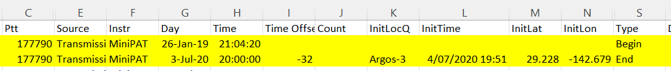

13. Now we are ready to Open R-studio and tidy and process the data with UKFSST. The two files we need for R (for miniPAT tags) are the Locations.csv and Lightlocs so we can match dawn/dusk. We need to also make sure that Lighlocs.csv has same deploy / pop-off info as Locations.csv.

UKFSST and the script require two functions to be run before you run the script

1. Make sure both functions fit2csv.R and get.sst.from.server.R are both run in RStudio before starting to run the code … both functions should be in your environment before running the code



1. Run the code from the RMarkdown script: UKFSST Processing Script.Rmd
2. Make sure that the ‘final’ output from the UKFSST model has **day,mon,year, lat, lon only,** This is what we need for the SDM. It does not need SST, because we will be using remote sensed data for that.
3. If you have the GPE3 output of your tag (some people will not), plot each track next to each other and see whether there are any differences.
   1. Question - do we expect far fewer locations from gpe2? I think the answer is yes.

**Other examples of when/ which points to remove**

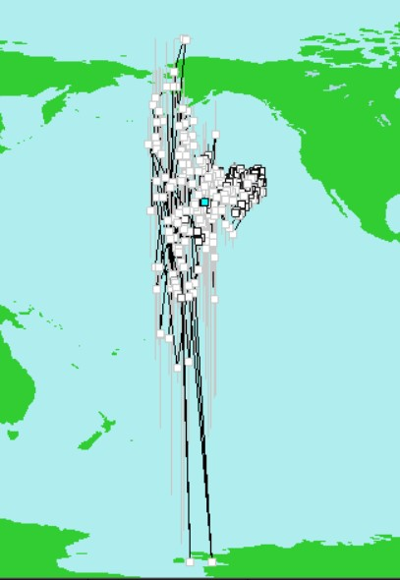

In this example, Dan/Mitch suggest to remove the positions from Antarctica, but not from the northern hemisphere. As long as the longitudes are within the latitudinal bounds, keep them in (unless they are in Antarctica) ?

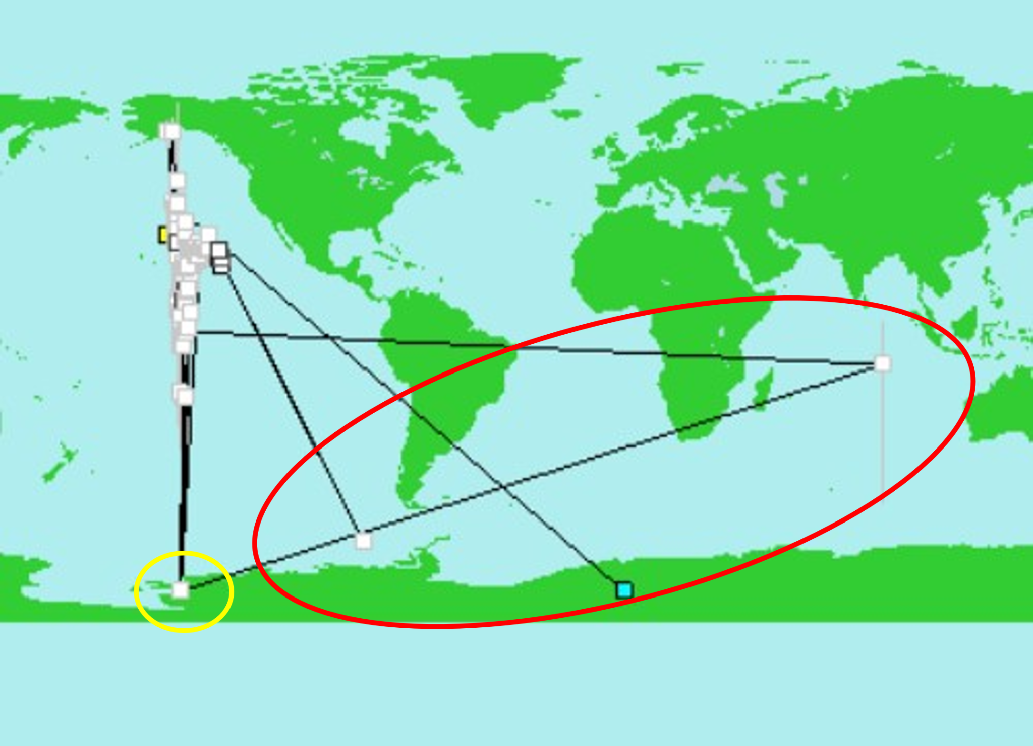

In this example - we would reject the extremely erroneous points in the red circle within the DAP. Dan suggests these positions are most likely a function of corrupted light days and nothing will overcome that. Also reject the point in Antarctica (but not those in the northern hemisphere). The extreme latitudes are probably a result of equinoxes. Below are some instructions on how to run uKFSST with longitude and SST, where Lat in blank. This allows the model to find a latitude using longitude and temperature.

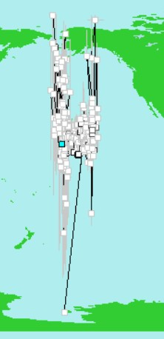  
I would only reject the one position down in Antarctica. It clearly has a substantial longitudinal movement, which to me indicates a bad light day. But that is the only one. I would handle the others similarly to what is described in 6.

**DAP meeting with Mitch and Dan - Notes**

* Straight to edit deploy info (they dont bother with clock correctison)
* Recalculate longitude for all messages -
* If the longs are joined by a straight line - this is a ‘rejected file’ - sometimes you can go back into the rejeccted files and accept them.. If we have gaps with lots of transmissions data
* Then ‘Iterate lat//long for all messages’ ::
* Pay attention to longitude rather than latitude…
* Then after iterations, reject locations that have wildly unusual latitudes
* Then file - save changes and close
* Then export decoded data - it is good to save workplace so then you dont have to re-iterate every time you do it.
* Still need to add in deploy date lat/long into the Locations.csv file at the end before pulling into R for UKFSST.
* Data around equinox’s we want to include - this is data around September/March ** but the day length is different
* If longitudes are in the same ‘zones’, its ok to keep them. . i.e. if a point is in alaska on land but in the same ball park as the rest of the longitudes, do not remove them. If bounds are out of longitude .. we dont want to subjectively remove positions i.e. even if they are in 12N.
* Latitude doesn’t matter - so dont stress about values that are latitudinally out of bounds..
* Dont use ‘keep off land’ function.. If the longitudes are within the bounds of the others, don’t reject them with the keep off land. BUT if the latitude is very out there i.e. Antarctica it is ok to reject this, based on the likelihood that these are poor light level data.
* Day length is proxy for latitude **
* To choose SST - pick one SST value per day from the night tiem.
* Plot the modelled runs with all lat/longs in there and from the plots, we can delete extreme latitudinal estimates.
* Dont recover sst field after removing latitude values from dataframe.

DON’T REMOVE POINTS FROM LAND IN DAP AND remove them later if needed when modeling. When we remove them initially the model converge bc it has less points or issues but we may lose information.

Remember to include from the Locations.csv file after processing in DAP, the first deploy date and position from the metada file and the last location with Argos=3 most similar to the metada file (remove the rest of positions, only keep one).

fit.2190190 <- kfsst(t2190190_2,

fix.last = T,

u.a = T,

v.a = T,

D.a = T,

**bx.a = F, #** because we measured SST so we dont want to bias SST, we want to force model to fit these .. this is longitude - we set these as FALSE this does not default to this.if change this default to TRUE its going to smooth out the longitude

by.a = T,

**bsst.a = F, # bec**ause we measured SST so we dont want to bias SST, we want to force model to fit these a

sx.a = T, #error

sy.a = T, #error

ssst.a = T)

These parameters we want to force ..

**OLDER NOTES HERE**

**Questions**

What to do with double tagged animals? MiniPAT/SPOT?

What if there are no pop-off lat/lon?

What file should you import to DAP if they are not recovered tags?

Are messages like this ok? 80% successfully decoded?

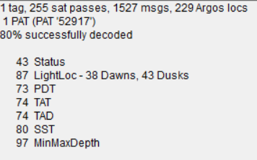

Another error message I received - 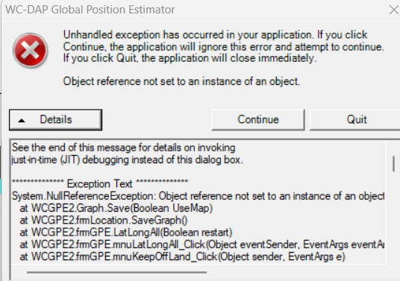

**Suzy’s way to DAP process**

1. Open DAP > File > Import Tag Data > From File > choose .wch (for fully transmitted / recovered tags) or All.csv or the .prv files for non-recovered tags.
2. Check clock corrections - check they are in seconds (if hours - issues) - check also start date matches with metadata deploy date
3. Open Tags > Light Level Global Position Estimator. This automatically started to analyze the data but I stopped it
4. Then I went to Settings > Edit Deploy/Popup Information and entered the tagging and recovery times and locations in the WC_DAP Global Position Estimator window
5. Lat-Long - ‘recalculate Longitude for all messages’ - If the error message comes up do we want to continue processing from where you left off - say **NO and start process again**
6. Lat-long - ‘Iterate lat/long for all messages’ and allow it to re-run..
7. Clean up - keep off land - then if some are still looking funky - select ‘Filter poor locations to rejected folder’
8. File - save changes and close
9. File - export decoded data -
10. If after exporting all GPE2_csvs the deployment date does not come up in the ‘locations.csv’ add in deploy date and lat/long as first row. This will be needed for .txt file! **   
    **Question for Suzy - should we add the deploy date into the locations.csv first and then run the UKFSST code? Or add it in after?
11. Tags - Known Location - add in deployment location only
12. Then go to Tags - Clock Correction - (should be seconds, several hours is not fine)
    1. These should follow date/times in the .rtc file.
    2. If its off by hours, we can infer it from the other data.. **if off by hours contact wildlife contact.
13. Tags - Light level geoposition estimator - do not abort - let it run
14. Latitude calibrator - curve trying to fit theoretical curve to our data curve
15. This is example of good fit . If near equinox will look flatter…

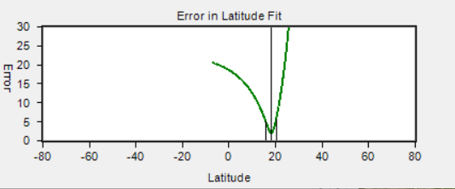

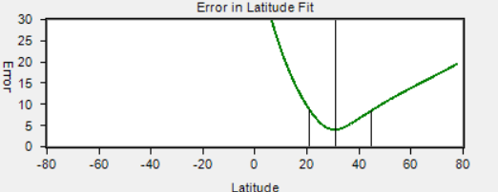

this plot is less good fit

1. Lat-lon - Interactive Latitude Calibration - ()

**Questions for Dan/Mitch**

1- Molly has a tag deployed in the coast of CA. We entered the lat/lon in DAP but when processing, it doesn’t take these points (deploy and pop off) and the final track is in the middle of the ocean. Check deploy/pop off dates/positions. Following on - if the deploy location is not ‘taken’ by the model, Suzy said we should add this location to the first row of our locations.csv…thoughts?

2- Why are the two files Mitch used to run the model different? Which are the differences between both? Are they the same as combining the locations and sst files from the output from DAP?

3- How to convert/clean the dates with hours instead of seconds in the clock corrections settings in DAP¿? Send Suzy the tags to reprocess them again (make a list). Same for files with no SST. How are we gonna process these tags?

5- Is the model comparing the sst tag data with the remote sst data? What are the SST values that are one per day from the ‘fit’.. Is that what we add to the csv at the end?

6 - Talk us through the ‘fit’ parameters, do we need to know how to tweak them.. .  
# Fit the model :::: fit2 <- kfsst(tagData, bx.a=F, bsst.a=F) - what do these mean?

7 - We still get some SST values as NA, is this ok?

8 - ****if the tag folder doesn’t have SST how do we proceed?

9- is there a way we can compare UKFSST outputs with GPE3? Some sensitivity analysis?

10- How to know what locations constitute outliers?

Next steps!!!

1- What do we do with tags in hours and no seconds?

2- Nerea: cannot share Kim’s tag-she will process those tags

## Data sharing IATTC / SDM project